Karnataka Law Society’s

GOGTE INSTITUTE OF TECHNOLOGY

Udyambag Belagavi -590008

Karnataka, India.



A Course Project Report on

**StarLink**

Submitted for the requirements of 6th semester B.E. in ISE

for **“Distributed Computing System (18IS63)”**

**Submitted by**

**NAME USN**

**1) John Nixon 2GI19IS016**

**2) Hrutuja Patnekar 2GI19IS017**

**Under the guidance of**

Prof. Rakesh Kadkol

**Academic Year 2021-2022 (Even Semester)**

Karnataka Law Society’s

GOGTE INSTITUTE OF TECHNOLOGY

Udyambag Belagavi -590008

Karnataka, India.

**Department of Information Science and Engineering**



**Certificate**

This is to certify that the Course Project work titled **“StarLink”** carried out by **Students: John Nixon, Hrutuja Patnekar** bearing **USNs: 2GI19IS016, 2GI19IS017** is submittedin partial fulfilment of the requirements for 6th semester B.E. in **INFORMATION Science and Engineering,** Visvesvaraya Technological University, Belagavi. It is certified that all corrections/ suggestions indicated have been incorporated in the report. The course project report has been approved as it satisfies the academic requirements prescribed for the said degree.

Date: Signature of Guide

Place: Belagavi

Prof . Rakesh Kadkol

KLS Gogte Institute of Technology, Belagavi

Name of the Examiners Signature of the Examiners

1.\_\_\_\_\_\_\_\_\_\_\_\_\_\_\_\_\_\_\_ 1.\_\_\_\_\_\_\_\_\_\_\_\_\_\_\_\_\_\_\_\_

2.\_\_\_\_\_\_\_\_\_\_\_\_\_\_\_\_\_\_\_\_ 2.\_\_\_\_\_\_\_\_\_\_\_\_\_\_\_\_\_\_\_\_

CONTENTS:

1. [ABSTRACT: 4](#_Toc106357082)
2. [OBJECTIVES: 5](#_Toc106357083)
3. [METHODOLOGY: 6](#_Toc106357084)
4. [FUNCTION: 7](#_Toc106357085)
5. [WORKING: 8](#_Toc106357086)
6. [CONCLUSION: 9](#_Toc106357087)
7. [REFERENCES: 9](#_Toc106357088)

# ABSTRACT:

Starlink is a satellite internet constellation operated by SpaceX, providing satellite Internet access coverage to 33 countries. It aims for global coverage. Starlink provides high-speed, low-latency broadband internet across the globe. Within each coverage area, orders are fulfilled on a first-come, first-served basis.

SpaceX started launching Starlink satellites in 2019. SpaceX planed to launch Starlink satellites each two weeks during 2020. That suggests a production rate of 130 per month. It was probably below 50 in October with the delayed November launch caused by production problems. As of May 2022, Starlink consists of over 2,400 mass-produced [small satellites](https://en.wikipedia.org/wiki/Small_satellite) in [low Earth orbit](https://en.wikipedia.org/wiki/Low_Earth_orbit) (LEO), which communicate with designated ground [transceivers](https://en.wikipedia.org/wiki/Transceiver).

SpaceX expects to co-launch smallsats with the Starlink satellites, which could disguise production delays. The production rate could still be below 25 a week for some time.

# OBJECTIVES:

The Starlink mission under development by SpaceX has several objectives. The first is to develop a global satellite mega constellation that provides high speed internet access to those who currently have poor or no access to the internet. This will also provide a large source of income to SpaceX that will allow them to increase development on other projects such as Starship. The second objective is similar to the first, as any development on Starlink satellite constellations can also be applied to other bodies in the solar system, such as the Moon and Mars. Some of it’s features are as follows:

HIGH-SPEED, LOW LATENCY: With high speeds and latency as low as 20ms in most locations, Starlink enables video calls, online gaming, streaming, and other high data rate activities that historically have not been possible with satellite internet.

EASY TO SET UP: Your [Starlink Kit](https://www.starlink.com/kit) arrives with everything you need to get online including your Starlink, wifi router, cables and base. Starlink [requires a clear view of the sky to connect](https://support.starlink.com/?topic=4badc520-cf8e-b3aa-dd49-b731686d5bf1). Download the Starlink App to determine your best install location.

IDEAL FOR RURAL & REMOTE COMMUNITIES: Starlink is ideally suited for areas where connectivity has been unreliable or completely unavailable. People across the globe are using Starlink to gain access to education, health services and even communications support during natural disasters.

PRESERVING THE NIGHT SKY: Starlink leads the industry in innovations to reduce satellite brightness, minimize the impact on astronomy, and protect the natural night sky for all to enjoy.

KEEPING SPACE CLEAN: Starlink is on the leading edge of on-orbit debris mitigation, meeting or exceeding all regulatory and industry standards. At end of life, the satellites will utilize their on-board propulsion system to deorbit over the course of a few months.In the unlikely event the propulsion system becomes inoperable, the satellites will burn up in Earth’s atmosphere within 1-5 years, significantly less than the hundreds or thousands of years at higher altitudes.

ENGINEERED BY SPACEX: SpaceX is leveraging its experience in building rockets and spacecraft to deploy the world’s most advanced broadband internet system. As the world’s leading provider of launch services – and the only provider with an orbital class reusable rocket – SpaceX has deep experience with both spacecraft and on-orbit operations.

# METHODOLOGY:

To understand Starlink you first have to understand Elon Musk, the man who runs SpaceX. He is not that easy to understand but the short answer is a man with the ego of Donald Trump with brains. A lot of brains and willing to take risks. Ted Turner, Gates and Wozinak were the founding fathers of these new men. The literally do seek to go where no man has gone before.

The supposed goal of Starlink is to bring the internet to areas that have no coverage. If you believe that I have a bridge you need to buy.As soon as SpaceX gets enough satellites up they want to link them together with lasers. That really reduces latency. He will then undercut the existing broadband market forcing them to give up the obscene profits they have been making off you but he can still undercut them. They will have a small edge but price won't be it. He will make the obscene profits and still undercut his competition. He will take over telecommunications.

Orbital mechanics, on board thrusters, planning, specific launch windows.From your initial orbital insertion, small amounts of thrust can alter individual units’ orbital path significantly. Each [Starlink](https://www.starlink.com/" \o "www.starlink.com" \t "_blank) satellite has a krypton based ion thruster capable of delivering small amounts of thrust over a long period of time, suitable for altering those paths, and for orbital maintenance, and for deorbiting when the useful life of the satellite is over.

By planning the launch to hit the center of the range of desired orbits, you maximize the potential spread of multiple satellites.By planning, you can figure out how to best put up a series of such miniature swarms to gradually set up wider and wider, and eventually complete, coverage.The key, then, is to launch at a specific time so your separation moment is at your target position.

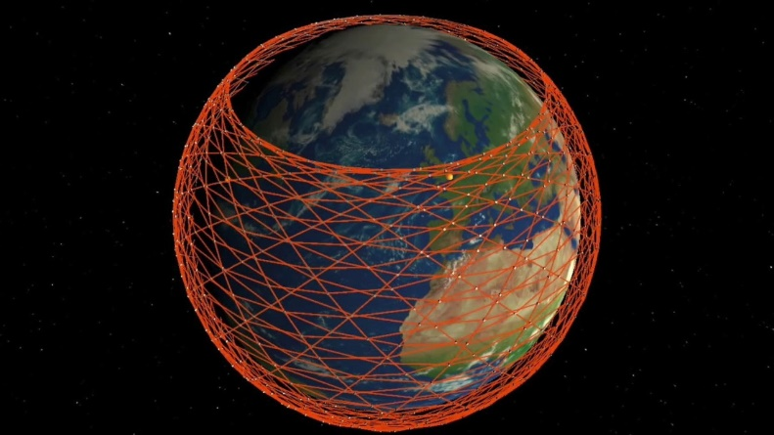

Figure :Lauch Windows

# FUNCTION:

Each satellite in the Starlink project weighs just 573 pounds (260kg). The body of each satellite is flat, and up to 60 of them can fit into one of SpaceX’s Falcon 9 rockets. Once put in orbit, a single large solar array comes out to power the satellite. The central portion includes four powerful antennas for internet transmissions. Each satellite relies on a set of lasers to connect with four others in orbit. Finally, they have ion thrusters that use krypton gas. This allows them to stay in orbit longer, even at these lower distances from Earth.

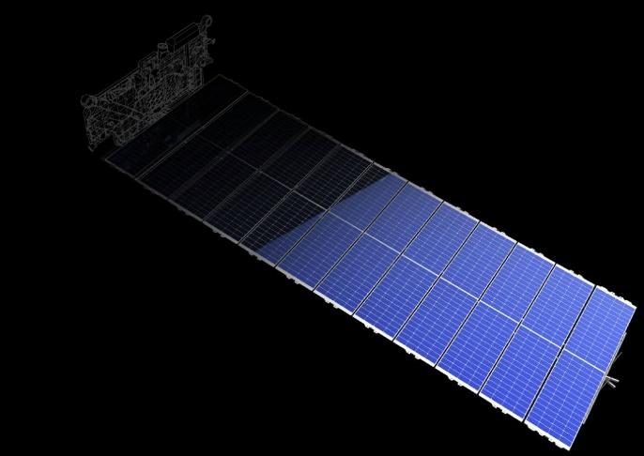

The purposes of the Starlink program (which will involve many satellite launches) are:

1. to provide high-speed internet service to paying customers around the world, especially in regions where ground-based high-speed internet service is either unavailable or is expensive to an impractical degree.
2. to provide a particular kind of high-speed internet to paying customers around the world, but especially to those who want high internet speed for uses that demand not merely high speed for downloads or uploads (as measured for example in seconds or minutes to download a program), but also in another aspect of internet speed called latency. For high-value users the Starlink satellite network will be much more valuable than existing networks, and will command a premium price.
3. Spacex expects to make a great deal of money from this world-wide, high speed, low-latency network. That income will pay for extending network services where none are available, subsidizing the price for the impoverished, and funding other Musk projects, such as colonizing Mars. It’s good to have a hobby.

# WORKING:

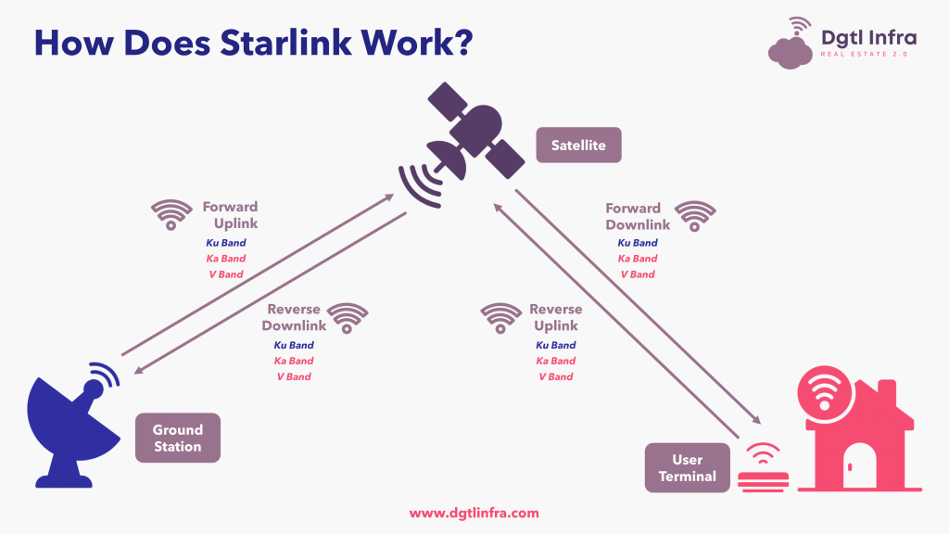

Originally, SpaceX planned to connect every satellite to its neighbors using lasers that would let the spacecraft communicate with one another. But the first batch of Starlink satellites launched without this ability.

So for now, service relies on a system of ground stations called gateways. These stations are positioned around the world and exchange signals with the Starlink satellites, tapping them into existing fiber-optic infrastructure. So, a user's home antenna connects to a Starlink satellite as it passes overhead, which in turn links them into the nearest gateway. As a result, in addition to their own antenna, users need to have a ground station within roughly 500 miles of their location to get service.

Things wont stay that way for long, though. Starlink engineers have already experimented with a batch of test satellites that uses lasers to communicate. Instead of connecting people to a nearby ground station, the lasers would let the satellites talk to each other directly at the speed of light, which is faster in the vacuum of space than in fiber optic cables. In a Reddit AMA ("Ask Me Anything") session, company engineers said the tech is still too expensive and challenging to manufacture in volume, but they expect it to roll out in future generations of satellites.

The Starlink launches have now become so routine that last month, SpaceX marked its 100th consecutive successful Falcon 9 launch. Even with just a portion of the eventual constellation deployed, more than 10,000 customers already have been given access to a beta version of Starlink’s internet service. It’s now clear that SpaceX not only has revolutionized the rocket launch industry, but also figured out how to use those rockets to take advantage of the rapid miniaturization of modern electronics.

# CONCLUSION:

It's looking increasingly likely that Starlink will help solve high-speed internet problems in at least some rural areas. And with Musk planning to eventually launch hundreds of Starlink satellites with each launch of SpaceX's Starship vehicle, much of the planet could someday get its internet signal from space. At one point, the company said it was making six Starlink satellites every single day.

The lingering question now is how many competitors will follow suit, and how many satellites will ultimately make up these mega constellations?

# REFERENCES:

* <https://www.starlink.com/>
* <https://en.wikipedia.org/wiki/Starlink>
* George Coulouris, Jean Dollimore, Tim Kindberg: Distributed Systems Concepts and Design, Pearson Education, Third edition
* Dan Marinescu: Cloud Computing Theory and Practice, ELSEVIER